**DAILY ONLINE ACTIVITIES SUMMARY**

|  |  |  |  |  |  |  |  |
| --- | --- | --- | --- | --- | --- | --- | --- |
| **Date:** | **3/06/2020** | | | | **Name:** | **Tushit Shukla** | |
| **Sem & Sec** | **4 sem & B sec** | | | | **USN:** | **4AL18CS093** | |
| **Online Test Summary** | | | | | | | |
| **Subject** | | OOC | | | | | |
| **Max. Marks** | | **30** | | **Score** | | **12** | |
| **Certification Course Summary** | | | | | | | |
| **Course** | 1. Java programing | | | | | | |
| **Certificate Provider** | | | **Great Learning** | **Duration** | | | **1s hr(spent by me on that day to learn)** |
| **Coding Challenges** | | | | | | | |
| **Problem Statement:**  1 To illustrate: largestSwap(27) ➞ false largestSwap(43) ➞ true If 27 is our input, we should return false because swapping the digits gives us 72, and 72 > 27. On the other hand, swapping 43 gives us 34, and 43 > 34. Examples largestSwap(14) ➞ false largestSwap(53) ➞ true largestSwap(99) ➞ true | | | | | | | |
| **Status: Completed** | | | | | | | |
| **Uploaded the report in Github** | | | | **Yes** | | | |
| **If yes Repository name** | | | | <https://github.com/tushitshukla29/lockdown-program> | | | |
| **Uploaded the report in slack** | | | | **Yes** | | | |

**Online Test Details**

Ooc test-

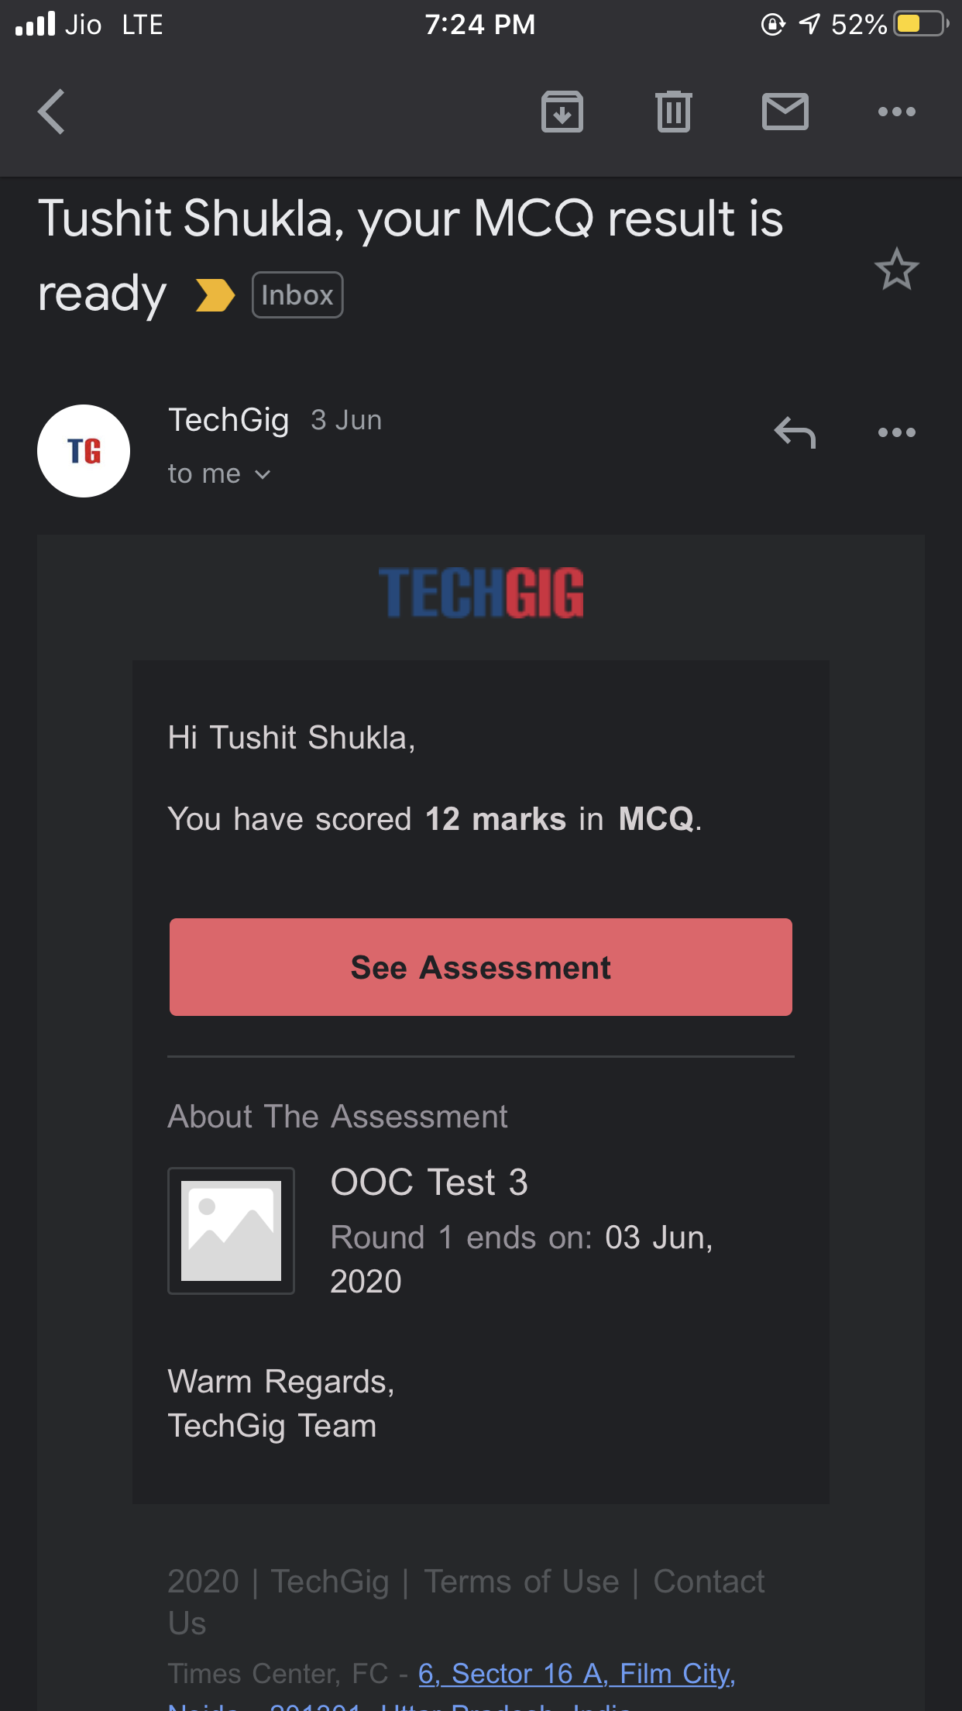

**Online Certification Details**:

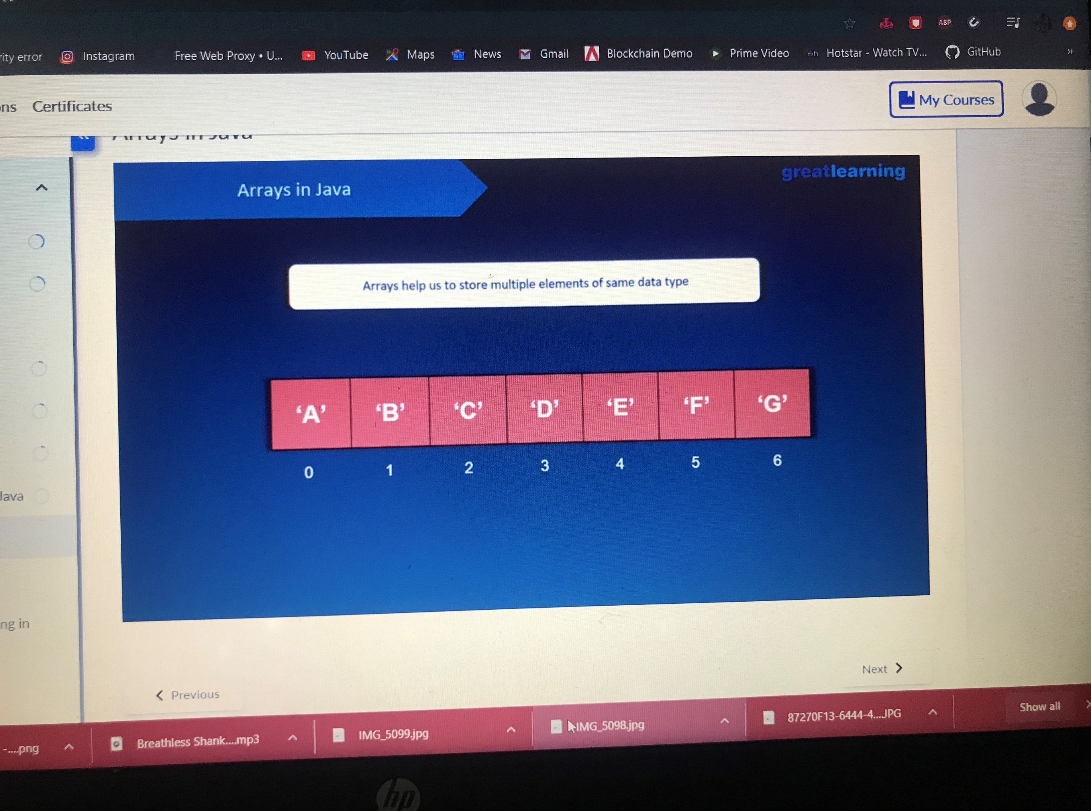

**Coding Challenge Detail :** I have written programs and uploaded it to my Github repository.

Link as follows: <https://github.com/tushitshukla29/lockdown-program/blob/master/largest%20swap>